VPC task - 03  
  
Design and deploy a scalable network architecture using AWS Transit Gateway to simplify network connectivity between multiple VPCs.   
  
  
Done on within the region , working on other regions  
  
4 vpcs  
  
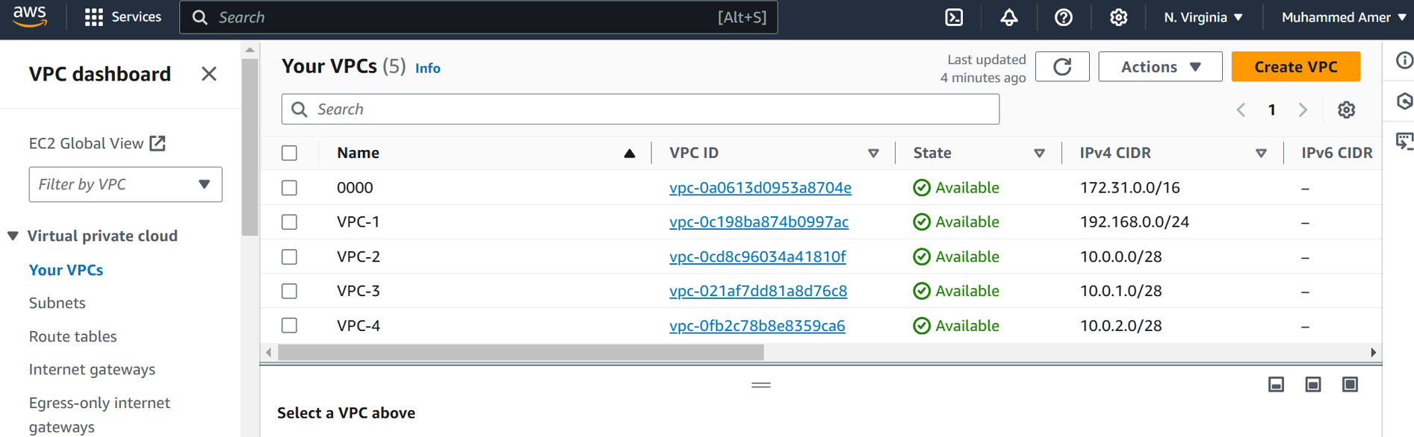  
  
  
4 Subnets  
  
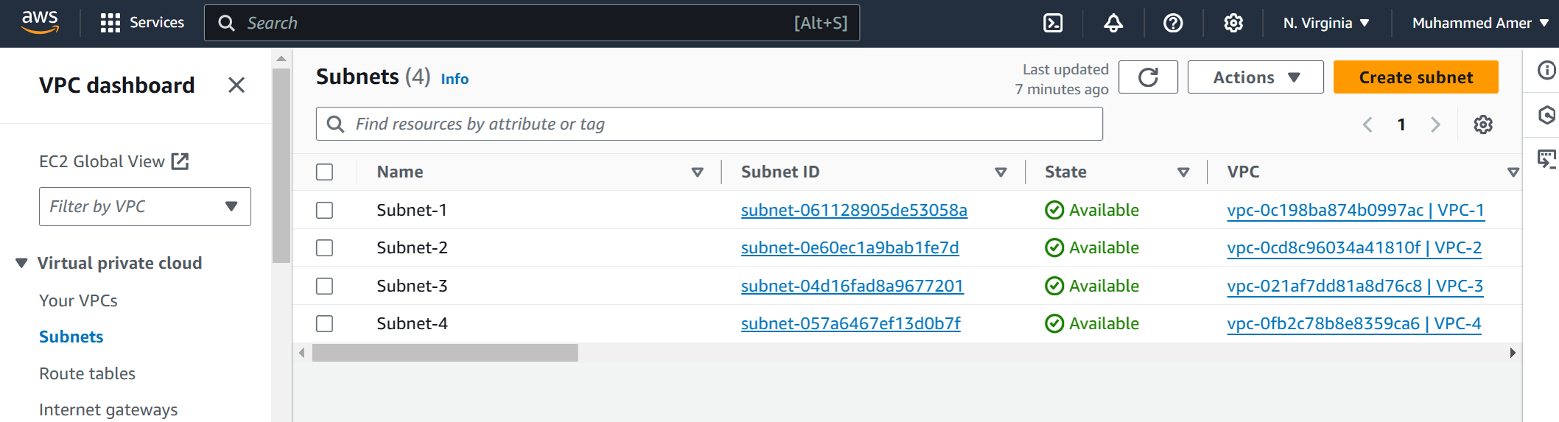  
  
  
  
  
  
  
  
  
  
  
  
  
  
  
  
  
  
  
  
Attached transit gateway to every VPC  
  
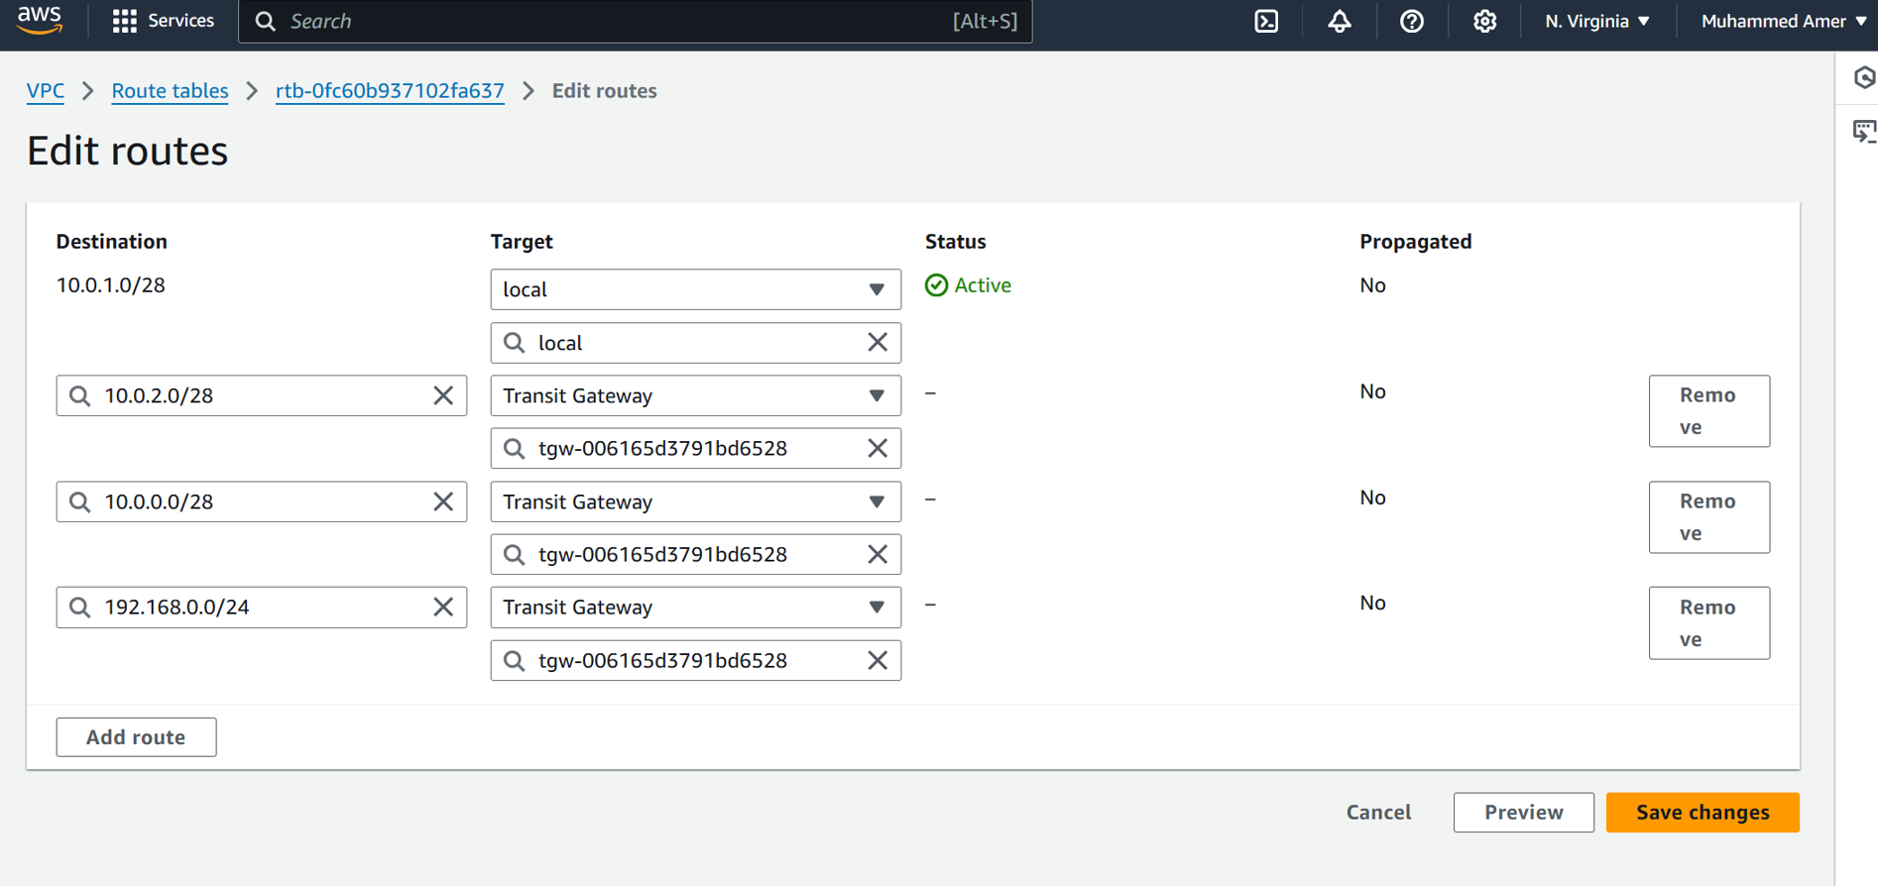  
  
  
  
  
  
  
  
  
VPC 1 to VPC 2  
  
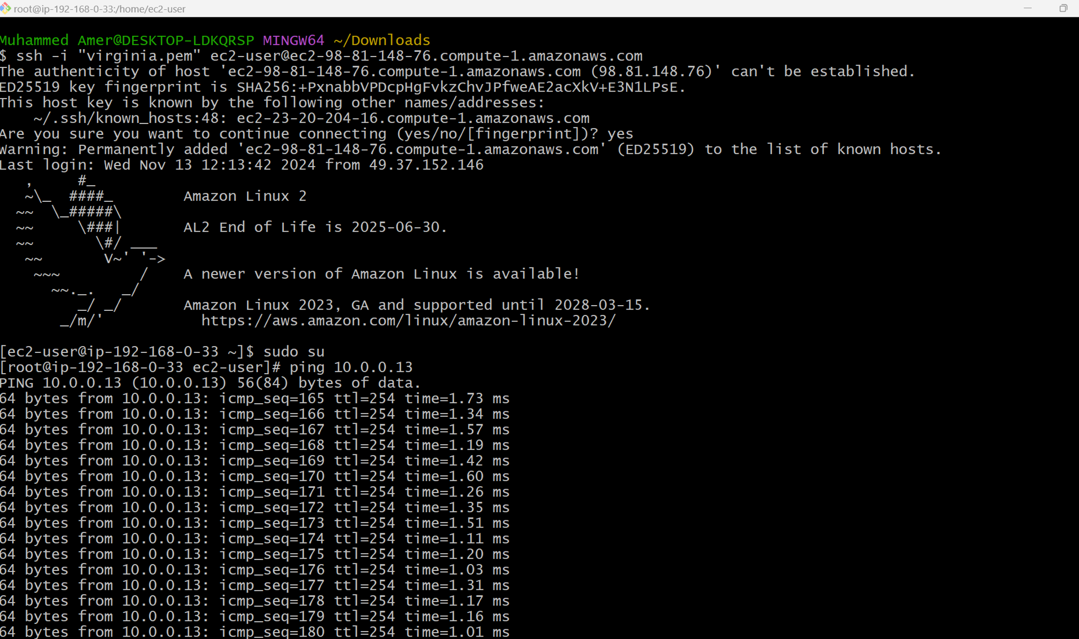  
  
  
  
  
  
VPC 1 to VPC 3  
  
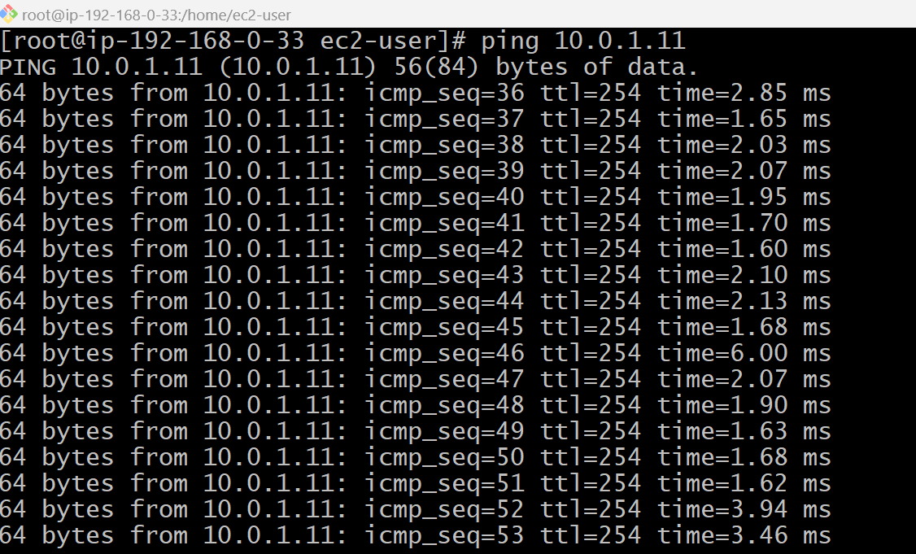  
  
  
  
  
  
  
VPC 1 to VPC 4  
  
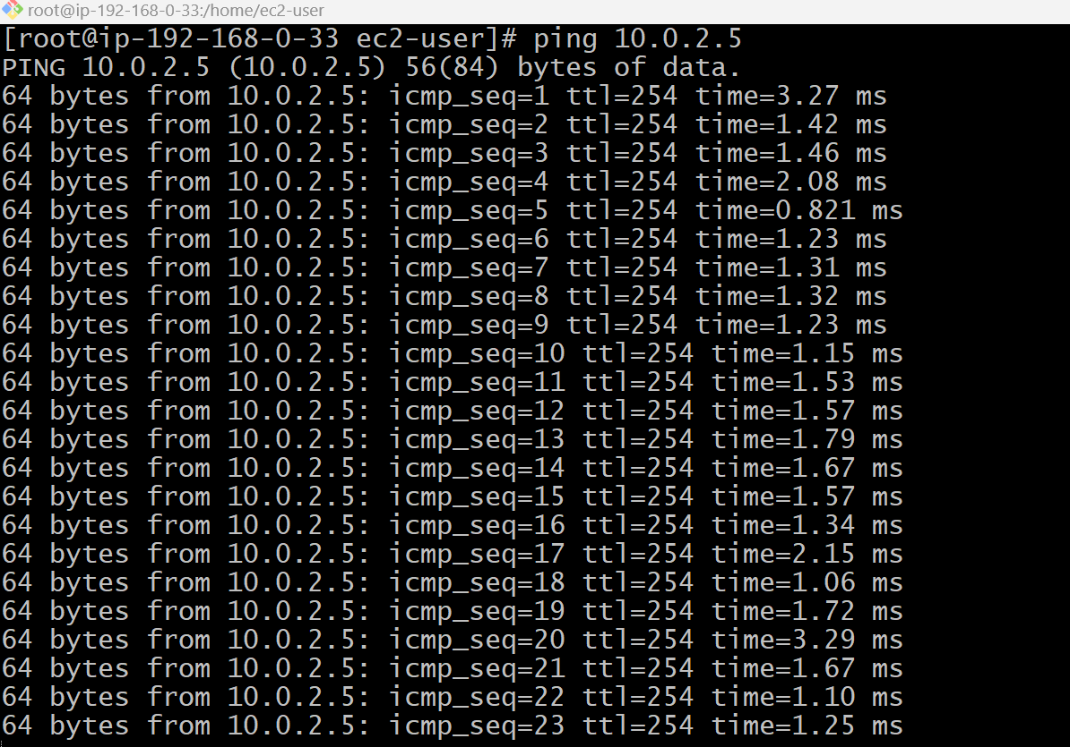  
  
  
  
VPC 4 to VPC 1  
  
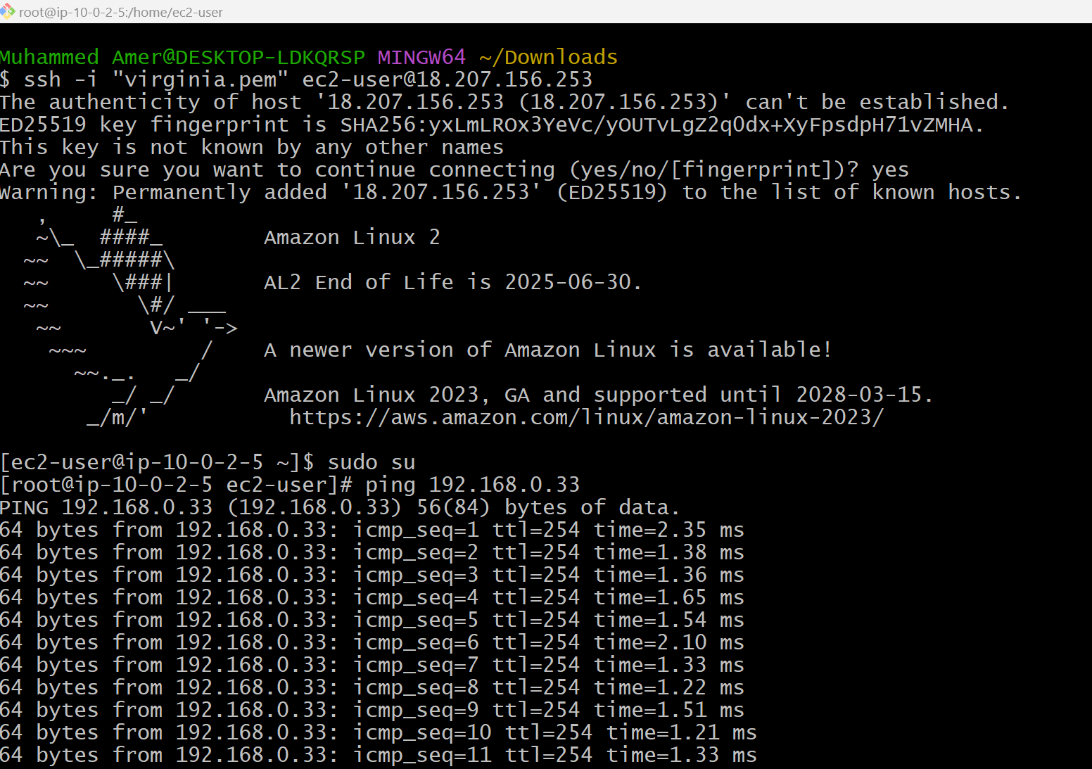  
  
  
  
  
  
Configure VPC endpoints to securely access AWS services without internet gateways or NAT gateways, ensuring data privacy and minimizing exposure to external threats.  
  
